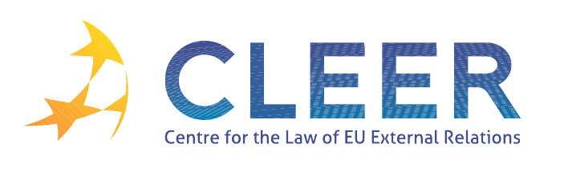

News Service week 42/2012

(15 – 21 October 2012)

- EUROPEAN NEIGHBOURHOOD POLICY
15 October | Foreign Affairs Council meeting: Conclusions on Bosnia and Herzegovina  Foreign Affairs Council meeting: Conclusions on Belarus  Foreign Affairs Council meeting: Conclusions on Georgia
17 – 19 October | Civil Society from the Euro-Mediterranean region at annual summit to discuss women’s rights, freedom of the media and corruption

- TRADE AND INVESTMENT
15 October | EP Report: On trade and economic relations with the United States
16 October | Communication from the Commission: On bilateral investment agreements between Member States and third countries
16 October | Trade Commissioner Karel De Gucht on the EU-Republic of Korea Free Trade Agreement: one year after its entry into force

- CFSP
15 October | Council Conclusions on the situation in Mali
15 October | Council Decision concerning restrictive measures against Belarus
15 October | Council Regulation concerning restrictive measures in respect of Somalia
15 October | Council Regulation concerning restrictive measures on Eritrea

- DEVELOPMENT AND COOPERATION
15 October | Main results of the Foreign Affairs Council meeting
15 October | Syria: Sanctions against the Syrian Regime once more strenghtened
15 October | Iran: EU strenghtens sanctions over lack of progress in nuclear talks
15 October | Cyprus Presidency of the Council says, Nobel Peace Prize increases EU responsibility for peace efforts especially in the EU’s Southern Neighbourhood
15 October | Council Conclusions: The roots of democracy and sustainable development: Europe’s engagment with Civil Society in external relations
15 October | Council Conclusions on the Annual Report 2012 on the EU’s development and external assistance policies and their implementation in 2011
15 October | Council Conclusions on social protection in EU’s development cooperation
16 October | Joint Meeting of the Committee on Foreign Affairs and the Delegation to the EU-Kazakhstan, EU-Kyrgyzstan and EU-Uzbekistan Parliamentary Cooperation Committees, and for relations with Tajikistan, Turkmenistan and Mongolia
16 October | European Development Days 2012: Eradication of hunger a priority
17 October | Development Commissioner Andris Piebalgs: 3 pillars to establish a poverty-free world
17 October | EP Committee on Development (DEVE): Countries in need deserve coherent EU policy
17 October | Malawi: Cooperation with EU to help the poorest and to improve agricultural production
Eurobarometer | More solidarity towards the poorest countries: broad support for development aid by EU citizens, new survey reveals

- EXTERNAL DIMENSION OF AFSJ
17 October | Common European Asylum System: State of play

- EU – Russia
17 October | Commission proposal: On the position to be taken on behalf of the EU within the Agreement on partnership and cooperation with Russian Federation

- EU – UN
17 October | Commissions and UN Women launch new partnership on women’s empowerment

- VACANCIES & EVENTS
Application deadline:  1 November | Researcher on EU Politics and Institutions - The Centre for European Policy Studies (CEPS, Brussels, BE)
23-24 October | At the Service of External Action (Seminar organized by Egmont – Royal Institute for International Relations, the Geneva Centre for Security Policy and the Royal Higher Institute for Defence, Brussels, BE)
25-26 October | EU External Relations and European-Level Diplomacy (Seminar organized by EIPA, Maastricht, NL)
25-27 October | Environmental Protection in the Global Twentieth Century: International Organizations, Networks and Diffusion of Ideas and Policies (Conference at the Free University of Berlin, Berlin, D)
29 October | The Future of the European Union – Challenges and Opportunities (Workshop organized by King’s College London, London, UK)
9 November | Linking trade and non-commercial interests: the EU as a global role model? (Workshop organized by CLEER and T.M.C. Asser Instituut, in cooperation with Vrije Univesiteit Amsterdam (Centre for European Legal Studies), The Hague, NL)
15 – 16 November | Improving Member States’ Asylum Systems and Defining Good Practices (Seminar organized by European Institute of Public Administration (EIPA) in Maastricht, NL)
18 – 28 November | MATRA Pre-Accession Training Programme (MATRA PATROL) – Access to Justice (Training Programme organized by T.M.C. Asser Instituut, The Hague, NL)
29 November –  1 December | The Future of Transnational law: EU, USA, China and the BRICS (Workshop organized by Peking University School of Transnational Law, Shenzen, CH)
Call for papers  Deadline: 15 November | The EU and the Emerging Powers (Conference at the European Parliament on 29-30 April, 2013)
Edited by Petr Pribyla & Dr. Tamara Takács

