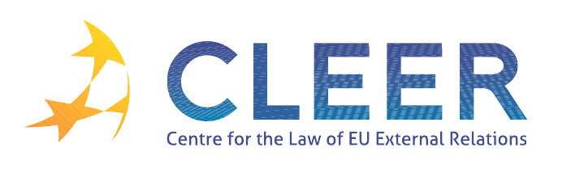

News Service weeks 33-34/2012

(13 – 26 August 2012)
- EUROPEAN NEIGHBOURHOOD POLICY
16 August | European Union mobilises to protect the environment in Algeria
23 August | European Commission announces support for justice and migration in Azerbaijan

- TRADE AND INVESTMENT
22 August | EU welcomes Russia's WTO accession after 18 years of negotiations

- DEVELOPMENT AND COOPERATION
13 August | European Commission mobilises emergency aid to help flood victims in the Philippines
20 August | Commission Communication: Social Protection in European Union Development Cooperation
24 August | Seychelles businesses to benefit from EUR 5m European Investment Bank funding

- VACANCIES AND EVENTS
Application deadline: 30 September | Enlargement and Integration Action: 5 positions for scientists available at the JRC
21-22 September | Turkey and the EU: rethinking a multifaceted relationship (Interdisciplinary workshop hosted by Tilburg University, NL)
27-28 September | Managing the New Migration and Security Challenges (Seminar organized by EIPA, Istanbul, TK)
5-6 October | The European Union and World Politics (Buffalo, NY, USA)
23-23 October | At the Service of External Action (Seminar organized by Egmont – Royal Institute for International Relations, the Geneva Centre for Security Policy and the Royal Higher Institute for Defence, Brussels, BE)
25-26 October | EU External Relations and European-Level Diplomacy (Seminar organized by EIPA, Maastricht, NL)
25-27 October | Environmental Protection in the Global Twentieth Century: International Organizations, Networks and Diffusion of Ideas and Policies (Berlin, D)
9 November | Linking trade and non-commercial interests: the EU as a global role model? (Workshop organized by CLEER and T.M.C. Asser Instituut, in cooperation with Vrije Univesiteit (Centre for European Legal Studies))

Edited by Dr. Tamara Takács

