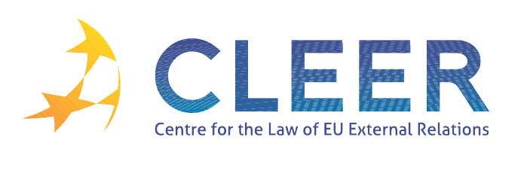

News Service week 15/2012

(9 – 15 April 2012)
- EU – WIDER EUROPE
11 April | MEPs achieve progress on energy security, trade and human rights in meeting with EU’s Eastern Partners

- TRADE
10 April | EU and US adopt blueprint for open and stable investment climates

- G-8
12 April | G8 Foreign Ministers meeting chair’s statement

- EXTERNAL DIMENSION OF AFSJ
12 April | Council 2011 annual Report on coordination of cooperation in combating organised crime, especially drug trafficking, originating in West Africa

- DEVELOPMENT AND COOPERATION
11 April | Commission’s response to the Sahel food crisis
11 April | Commissioner Georgieva warns of possible humanitarian disaster in northern Mali
12 April | New EU-Pacific development partnership to tackle climate change and fight poverty
12 April | Barroso on access to sustainable energy in developing countries as one of the top priorities of the EU development policy
13 April | Survey reveals that the EU should support developing countries in energy access Eurobarometer survey details

- EU – MIDDLE EAST
11 April | Middle East Quartet Statement

- EU – MONGOLIA
12 April | Framework Agreement on Partnership and Cooperation between the EU and its Member States, of the one part, and Mongolia, of the other part

- EVENTS
19 April | ‘The experiences of the Polish Presidency of the Council of the EU in the field of external relations’, Presentation organised by T.M.C. Asser Instituut, CLEER, and the Embassy of the Republic of Poland in The Hague, NL
3-5 May | ‘The European Union in International Affairs III’, Conference organised by IES-VUB, IEE-ULB, UNU-CRIS and EUIA, Brussels, BE
4-5 May | ‘Enlargement and Integration in the European Union: Wider and Deeper?’, Workshop organised by Rutgers University, New Brunswick, US
10-11 May | ‘One year after the Arab Spring: The European Union’s relations with the Southern-Mediterranean region’, Conference organised by CLEER, Universidad Pablo de Olavide and the T.M.C. Asser Instituut, Seville, Spain
25 May | ‘Human rights and the EU crisis management operations: a duty to respect and to protect?’ Workshop organised by T.M.C. Asser Instituut, CLEER and NLDA, The Hague, NL
19 June | ‘Legal Approximation and Application of EU law in the Eastern Neighbourhood of the European Union: Towards a Common Regulatory Space?’, Conference organised by Gent University, Ghent, BE

Edited by Linda Krӕmer & Dr. Tamara Takács

