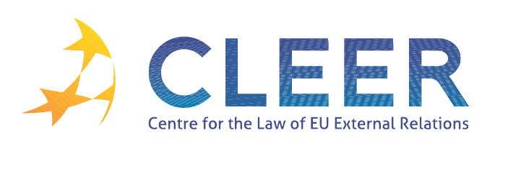

News Service week 10/2012

(5 – 11 March 2012)
- EU – WIDER EUROPE
7 March | EU-Armenia: Joint work on partnership for reform

- EU – RUSSIA
6 March | Russia's elections: Putin wins amid signs of change

- EU – MEDITERRANEAN
8 March | Jobs and stability: EU-Tunisia industry cooperation forges ahead
ISS publication | ‘Listening to unfamiliar voices: The Arab democratic wave’ by Álvaro de Vasconcelos

- EU – LATIN AMERICA
6 March | Council Decision authorising the opening of negotiations for an international agreement on the creation of the EU-LAC Foundation as an international organization - common guidelines

- CFSP
8 March | Council implementing Decision 2012/144/CFSP of 8 March 2012 implementing Decision 2010/656/CFSP renewing the restrictive measures against Côte d’Ivoire

- CSDP
6 March  European Economic and Social Committee | Opinion of the European Economic and Social Committee on ‘The role of the European Union in peace building in external relations: best practice and perspectives’

- TRADE
5 March | Summary record of the meeting of the European Parliament's Committee on International Trade (INTA), Brussels, 29 February - 1 March 2012

- DEVELOPMENT AND COOPERATION
6 March | European Commission announces increased humanitarian aid for the Democratic Republic of Congo
6 March | EU relations with the Democratic Republic of Congo
6 March | Morocco: Moving forward to more dynamic relations
6 March | Summary record of the meeting of the European Parliament's Committee on Development (DEVE) on 29 February -1 March 2012
9 March | European Commission: 32 million people benefited from EU actions on water

- ENVIRONMENT
9 March | Council meeting conclusions: Rio+20: Pathways to a Sustainable Future

- EVENTS
22-24 March | ‘19th International Conference of Europeanists’ conference organised by CES, Boston, USA
26-28 March | ‘Collapsing Europe?’ conference organised by Graduate Centre for Europe, Birmingham, UK
11-13 April | ‘Widening and deepening of European integration: Challenges and strategic choices facing the European Union’ conference organised by EUCE, Dalhousie University, Halifax, CA
13-14 April | The EU/US Transatlantic relationship: ‘Comparative policies and approaches to global challenges’ conference organised by the University of Illinois at Urbana-Champaign, USA
10-11 May | ‘One year after the Arab Spring: The European Union’s relations with the Southern-Mediterranean region’ conference co-organised by CLEER and others, Universidad Pablo de Olavide, Seville, ES

Edited by Zsófia Deli & Dr. Tamara Takács

