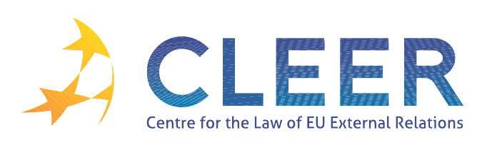

News Service week 8/2012

(20-26 February 2012)
- EU - MIDDLE EAST
21 February | First meeting of EU-Jordan Task Force to support the ongoing reforms in Jordan
21 February | The EU and Jordan: long-standing relationship

- EU - RUSSIA
20 February | European Parliament closely monitors upcoming presidential elections in Russia

- TRADE
20 February | EU launches free trade negotiations with Armenia
21 February | Report from the Commission to the European Council: Trade and Investment barriers Report 2012 (COM(2012) 70 final)
Commission Staff Working Document | Accompanying document to the Report from the Commission to the European Council: Trade and Investment barriers Report 2012 (COM(2012) 70 final)
22 February | European Commission agrees to refer ACTA (Anti-Counterfeiting Trade Agreement) to the European Court of Justice
22 February | European Parliament rapporteur welcomes referral of ACTA to Court of Justice
24 February | 20th Session of WIPO Intergovernmental Committee on Intellectual Property and Genetic Resources, Traditional Knowledge and Folklore (Geneva, 14-22 February 2012) - Final statements by the European Union and its Member States
EP Committee Opinion | Trade for change: The EU trade and investment strategy for the Southern Mediterranean following the Arab Spring revolutions (2011/2113(INI))

- G-20
24 February | EP representative: ‘Parliaments should play a larger role in global affairs’

- CFSP
AG Opinion | Case C-130/10 European Parliament v. Council of the European Union (Restrictive measures directed against certain persons and entities associated with Usama bin Laden, the Al-Qaida network and the Taliban – freezing of funds and economic resources – choice of legal basis – Articles 75 TFEU and 215 TFEU – entry into force of the Treaty of Lisbon – transitional provisions)

- AVIATION
22 February | Council Decision on the conclusion of a Memorandum of Cooperation between the European Union and the International Civil Aviation Organisation providing a framework for enhanced cooperation, and laying down procedural arrangements related thereto

- AREA OF FREEDOM, SECURITY AND JUSTICE
22 February Frontex | Frontex Programme of Work 2012
22 February | Frontex signs Working Arrangement with Armenia

- DEVELOPMENT AND COOPERATION
21 February | The EU renews its commitment to foster peace and security in Somalia
21 February | Libyan crisis factsheet
22 February | EIB funding helps launch Ethiopia’s largest cement plant
EUISS Analysis | Humanitarian crisis as a fresh justification for international action in Syria

- EVENTS
- March | ‘Keeping the EU’s External Borders Secure: Frontex and the use of new technologies’ conference organised by ERA, Trier, DE
26 March | ‘Family reunification procedures in European migration law’ conference organised by ERA, Riga, LV

Edited by Zsófia Deli & Dr. Tamara Takács

