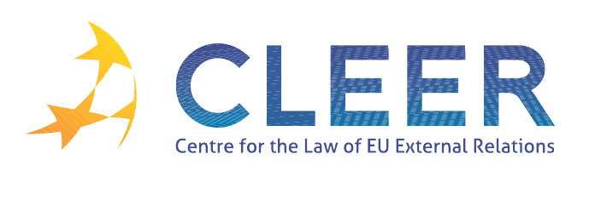

News Service weeks 35-36/2012

(27 August – 9 September 2012)
- EU ENLARGEMENT
3 September | Statement by Commissioner Štefan Füle and Secretary General of the Council of Europe Thorbjørn Jagland on the Road Map for Bosnia and Herzegovina's EU membership application and the execution of the European Court of Human Rights’ "Sejdić and Finci"- judgment

- EUROPEAN NEIGHBOURHOOD POLICY
29 August | Report from the Commission to the European Parliament and the Council on possible Migatory and Security Impacts of Future Visa Liberalisation for the Republic of Moldova on the European Union - Preliminary Assessment

- EASTERN PARTNERSHIP
28 August | New EU funding for judicial reform and economic integration in Armenia
28 August | European Commission announces new support for agriculture and food safety in Georgia

- HUMAN RIGHTS
3 September | Human rights: MEPs have high expectations of new EU envoy

- TRADE AND INVESTMENT
3 September | Summary record of the meeting of the European Parliament's Committee on International Trade (INTA), held in Brussels

- EEAS
5 September | Speech by President of the European Council Herman Van Rompuy at the Annual Conference of EU Heads of Delegation

- CFSP
EP Report | On the Annual Report from the Council to the European Parliament on the Common Foreign and Security Policy
30 August | CFSP Budget Report - Monthly update as of 31 August 2012

- DEVELOPMENT AND COOPERATION
6 September | COM(2012)489 European Commission’s Annual Report on the European Union’s Humanitarian Aid and Civil Protection Policies and their Implementation in 2011
7 September | European Commission increases its emergency aid in Syria
EP Study | Strengthening the Link between Relief, Rehabilitation and Development (LRRD) in the EU's Financing Instruments for Development and Humanitarian Aid under the MFF 2014-2020

- EXTERNAL DIMENSION OF AFSJ
28 August | COM(2012)472 Third Commission Report on the Post-Visa Liberalisation Monitoring for the Western Balkan Countries
29 August | Report from the Commission to the European Parliament and the Council on possible Migatory and Security Impacts of Future Visa Liberalisation for the Republic of Moldova on the European Union - Preliminary Assessment
30 August | Report on the priorities for the successful development of a common readmission policy (Partial declassification)
3 September | Summary record of the meeting of the European Parliament Committee on Civil Liberties, Justice and Home Affairs (LIBE), held in Brussels

- EU – JAPAN
3 September | EU-Japan Mutual Legal Assistance Agreement - Fact-sheet on the practical conduct of MLA procedures

- VACANCIES AND EVENTS
Application deadline: 30 September | Enlargement and Integration Action: 5 positions for scientists available at the JRC
21-22 September | Turkey and the EU: rethinking a multifaceted relationship (Interdisciplinary workshop hosted by Tilburg University, NL)
27-28 September | Managing the New Migration and Security Challenges (Seminar organized by EIPA, Istanbul, TK)
5-6 October | The European Union and World Politics (Buffalo, NY, USA)
22-23 October | ‘EU Governance of Global Emergencies’ Conference organized by Ghent University and University of Pisa (Palace of the Academies, Brussels, BE)
23-24 October | At the Service of External Action (Seminar organized by Egmont – Royal Institute for International Relations, the Geneva Centre for Security Policy and the Royal Higher Institute for Defence, Brussels, BE)
25-26 October | EU External Relations and European-Level Diplomacy (Seminar organized by EIPA, Maastricht, NL)
25-27 October | Environmental Protection in the Global Twentieth Century: International Organizations, Networks and Diffusion of Ideas and Policies (Berlin, D)
9 November | Linking trade and non-commercial interests: the EU as a global role model? (Workshop organized by CLEER and T.M.C. Asser Instituut, in cooperation with Vrije Univesiteit Amsterdam (Centre for European Legal Studies), The Hague, NL)

Edited by Dr. Tamara Takács

