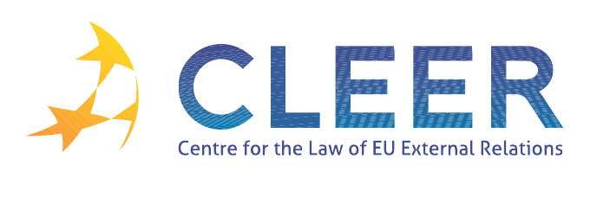

News Service weeks 27-28-29/2012

(2 – 22 July 2012)
- EU ENLARGEMENT
6 July | EU Candidate and Pre-Accession Countries Economies Quarterly - CCEQ  2nd quarter 2012

- EUROPEAN NEIGHBOURHOOD POLICY
13 July | EU announces new support for Lebanon
18 July | EU and Lebanon agrees on the next step to finalise Action Plan

- EU PRESIDENCY
4 July | Cyprus to present its programme for the EU Presidency

- TRADE AND INVESTMENT
4 July | European Parliament rejects ACTA
4 July | Better terms for EU firms in trade deals with Russia
18 July | Commission proposes to open negotiations for a free trade deal with Japan
18 July | COMMISSION STAFF WORKING DOCUMENT IMPACT ASSESSMENT REPORT ON EU-JAPAN TRADE RELATIONS Accompanying the document Recommendation for a Council Decision authorising the opening of negotiations on a Free Trade Agreement between the European Union and Japan
20 July | Concluding trade deals could boost EU’s GDP by 2%

- EU-UN
3 July | EU priorities for the 67th session of the General Assembly of the UN

- INTELLECTUAL PROPERTY
16 July | 22nd Session of WIPO Intergovernmental Committee on Intellectual Property and Genetic Resources, Traditional Knowledge and Folklore (Geneva, July 9-13, 2012) - Final statements by the European Union and its Member States on TCE

- CFSP
19 July | Judgment in case C-130/10, EP v Council (Restrictive measures directed against certain persons and entities associated with Osama bin Laden, the Al-Qaeda network and the Taliban; joint proposal)

- CSDP
16 July | Green light for civilian CSDP mission to assist in fighting terrorism in the Sahel
16 July | Council Decision 2012/389/CFSP of 16 July 2012 on the European Union Mission on Regional Maritime Capacity Building in the Horn of Africa (EUCAP NESTOR)

- DEVELOPMENT AND COOPERATION
9 July | Commission Communication: Improving EU support to developing countries in mobilizing financing for development COM(2012)366
11 July | The EU and the Philippines sign Partnership and Cooperation Agreement
13 July | EU aid for Senegal
18 July | EU development cooperation with Mozambique
20 July | EU development work in Tanzania
20 July | EU development cooperation with the Horn of Africa

- EXTERNAL DIMENSION OF AFSJ
10 July | European Asylum Support Office publishes Country of Origin Information report on Afghanistan (Taliban strategies – recruitment)
13 July | Positive Step for Common European Asylum System
19 July | Judgment in case C-451/11, Natthaya Dülger v Wetteraukreis (EEC-Turkey Association Agreement, interpretation of Association Council Decision No 1/80, right of residence divorced spouse of a Turkish worker) Opinion of AG

- EU – US
12 July | Joint EU – US statement on the Asia-Pacific region
12 July | EU and US agree to foster transatlantic SME cooperation
ISS Paper | Are Europeans a better transatlantic security partner than meets the eye? (by Patryk Pawlak and Clara O'Donnell)

- EVENTS
21-22 September | Turkey and the EU: rethinking a multifaceted relationship (Interdisciplinary workshop hosted by Tilburg University, NL)
27-28 September | Managing the New Migration and Security Challenges (Seminar organized by EIPA, Istanbul, TK)
5-6 October | The European Union and World Politics (Buffalo, NY, USA)
23-23 October | At the Service of External Action (Seminar organized by Egmont – Royal Institute for International Relations, the Geneva Centre for Security Policy and the Royal Higher Institute for Defence, Brussels, BE)
25-26 October | EU External Relations and European-Level Diplomacy (Seminar organized by EIPA, Maastricht, NL)
25-27 October | Environmental Protection in the Global Twentieth Century: International Organizations, Networks and Diffusion of Ideas and Policies (Berlin, D)
9 November | Linking trade and non-commercial interests: the EU as a global role model? (Workshop organized by CLEER and T.M.C. Asser Instituut, in cooperation with Vrije Univesiteit (Centre for European Legal Studies))

Edited by Dr. Tamara Takács

