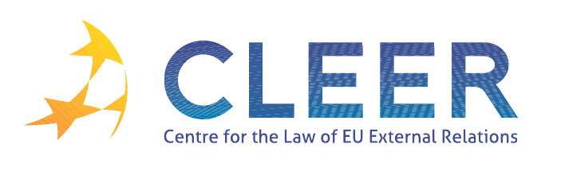

News Service week 14/2012

(2 – 8 April 2012)
- EU – WIDER EUROPE
3 April | Commissioner Füle at Euronest parliamentary assembly on plan to increase EU assistance

- TRADE
1 April | Commissioner De Gucht on trade and investment 2012 at EU-ASEAN Business Summit
4 April | Update on ACTA’s referral to the ECJ

- CFSP
2 April | Monthly update of CFSP budget report
3 April | High Representative Catherine Ashton on the Declaration of global principles for domestic election observation

- CSDP
2 April | Spokeswoman of the European Commission on strengthening EU-NATO relationship
European Defence Agency Report | Report on 2012 Annual Conference ‘Refocusing Defence’

- EXTERNAL DIMENSION OF AFSJ
2 April | Exemption from the visa requirement for holders of diplomatic passports from Kazakhstan with effect from 26 April

- DEVELOPMENT AND COOPERATION
4 April | Commissioner Piebalgs reaffirms the EU as the world’s largest aid donor in 2011 despite the crisis

- EU – MEDITERRANEAN RELATIONS
2 April | Commissioner Geoghegan-Quinn on research cooperation at Euro-Mediterranean Conference
2 April | EU multilateral relations with southern partners: reflections on future prospects

- EU – LATIN AMERICA
3 April | High Representative Catherine Ashton on the ratification of the Rome Statute of the International Criminal Court by Guatemala

- EVENTS
19 April | ‘The Future of Europe: Towards the European Dream?’, Seminar organised by Civitatis International and the Office of the European Parliament in London, UK
19 April | ‘The experiences of the Polish Presidency of the Council of the EU in the field of external relations’, Presentation organised by T.M.C. Asser Instituut, CLEER, and the Embassy of the Republic of Poland in The Hague, NL
19-20 April | ‘The EU and China – Partners for a Green World’, Conference organised by College of Europe, the Madariaga – College of Europe Foundation and distinguished Chinese partners, Brussels, BE
22-28 April | ‘EU Enlargement: Identities, Values and Market’, Seminar organised by Jean Monnet Chair of European Public Law, University of Zagreb, Faculty of Law, Croatia
23-27 April | ‘EU Diplomacy: Gaining valuable insight into the work of the EEAS’, Training programme organised by College of Europe, Bruge, BE
25 April | ‘Quo vadis EU: The EU Abroad in the World’, Webinar organised by the Institute for European Studies, Vrije Universiteit Brussel, online
26-27 April | ‘Management and Control Structures for Migration Funds’, Seminar organised by European Institute of Public Administration (EIPA), Maastricht, NL
27-28 April | ‘The Second Euroacademia Global Conference – Europe Inside-Out: Europe and Europeaness Exposed to Plural Observers’, Conference organised by Euroacademia, Paris, FR
10-11 May | ‘One year after the Arab Spring: The European Union’s relations with the Southern-Mediterranean region’, Conference organised by CLEER, Universidad Pablo de Olavide and the T.M.C. Asser Instituut, Seville, Spain
25 May | ‘Human rights and the EU crisis management operations: a duty to respect and to protect?’ Workshop organised by T.M.C. Asser Instituut, CLEER and NLDA, The Hague, NL
19 June | ‘Legal Approximation and Application of EU law in the Eastern Neighbourhood of the European Union: Towards a Common Regulatory Space?’, Conference organised by Gent University, Ghent, BE

Edited by Linda Krӕmer & Dr. Tamara Takács

