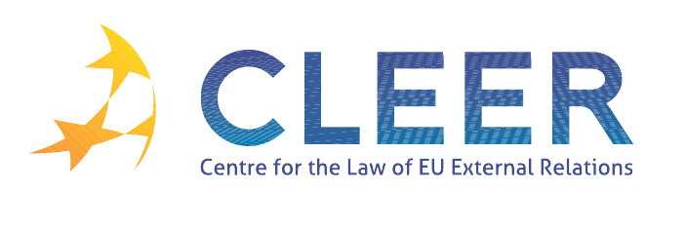

News Service week 7/2012

(13-19 February 2012)

- EU-CHINA
13 February | 14th EU-China Summit holds promise for a strengthened cooperation
13 February | EU-China Summit EU27 exports to China up by 21% and imports by 5% in the first ten months of 2011
14 February | EU-China Summit factsheet

- EU-USA
15 February | European Union and United States agree to historic new partnership on organic trade
16 February ISS paper | ‘Time for an honest audit of EU-US relations’

- EURO-MEDITERRANEAN RELATIONS
16 February | Information from the Presidency and the Commission: Euro-Mediterranean Employment and Labour High Level Working Group

- TRADE
13 February | Transparency of ACTA negotiations (Anti-Counterfeiting Trade Agreement)
14 February | European Parliament plenary meeting: Joint debate - EU-Morocco agreement on agricultural and fishery products
16 February | 29th Annual Report from the Commission to the European Parliament on the EU's anti-dumping, anti-subsidy and safeguard activities (2010) (SWD(2012) 9 final)

- CSDP
16 February | Military Advice on the draft Joint Council and Commission document "Comprehensive approach to the EU Implementation of the United Nations Security Council Resolutions 1325 and 1820 on women, peace and security" (COSDP 1094)
European Defence Agency | Factsheet: EU and US government spending on defence

- DEVELOPMENT AND COOPERATION
13 February | Meeting of the European Parliament's Committee on Development (DEVE) on 9  February 2012
14 February | Communication from the Commission to the European Parliament and the Council on operations carried out under the EIB external mandate in 2010 (COM(2012) 36 final)
Commission Staff Working Paper | Accompanying document to the Communication from the Commission to the European Parliament and the Council on operations carried out under the EIB external mandate in 2010 (COM(2012) 36 final)

- EXTERNAL DIMENSION OF AFSJ
Joint Staff Working Document | Second progress report on the implementation by the Republic of Moldova of the Action Plan on Visa Liberalisation
Joint Staff Working Document | Second progress report on the implementation by Ukraine of the Action Plan on Visa Liberalisation

- EVENTS
2 March | ‘Creating a sustainable energy future within the EU’ workshop organised by the University of Glasgow, UK
5-6 March | ‘China and Europe in 21st century global politics: Partnership, competition or co-evolution?’ workshop organised by the Graduate School of Global Politics of Free University Berlin, Beijing, CN
7 March | ‘Quo vadis EU: Foreign Policy vehicles and near neighbourhood’ webinar organised by the Institute for European Studies, BE
15-16 March | ’The management of migration and asylum in Europe: Current challenges and policy responses’ conference organised by the University of Cambridge, UK
30 March | ’European public diplomacy: Soft power at work’ workshop organised by the University of Southern California, USA

Edited by Zsófia Deli & Dr. Tamara Takács

