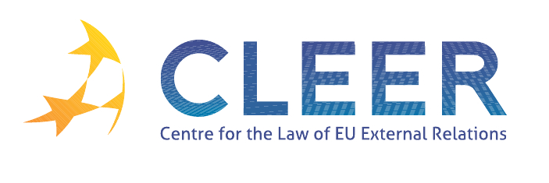

News Service week 5/2012

(30 January – 5 February 2012)
- EU-WIDER EUROPE
30 January Committee of the Regions | Euro-Mediterranean Regional and Local Assembly (ARLEM) plenary urges an innovative Euro-Mediterranean cohesion policy
Mercury Working Paper | ‘The EU Neighbourhood and Comparative Modernisation’
Mercury Working Paper | ‘The European Union and Multilateralism in the Mediterranean: Energy and Migration Policy’

- EU-RUSSIA
1 February | High Representative Ashton speaks at the EP on the situation in Russia

- EU-IRAN
30 January | EU and Iran: updated factsheet
1 February | MEP says on Iran nuclear crisis: “negotiations only alternative to war”
2 February | High Representative Ashton speaks at the EP: EU remains fully committed to achieve a diplomatic solution to the Iranian nuclear issue

- EU-MIDDLE EAST
3 February | Commissioner Füle discusses Kosovo’s next steps on EU path with country’s President
4 February | High Representative Ashton disappointed by the veto of UNSC Resolution on Syria

- EU-CHINA
1 February | Launch of ‘2012 EU-China year of intercultural dialogue’

- ECONOMIC AND MONETARY AFFAIRS
30 January | Treaty on Stability, Coordination and Governance in the Economic and Monetary Union: The fiscal compact ready to be signed (text of the new treaty )

- TRADE
30 January | WTO rules in favour of EU against China's export restraints on raw materials (AB report )
3 February | European Parliament holds debate on EU foreign policy towards the BRICS and other emerging powers

- DEVELOPMENT AND COOPERATION
31 January | Commission allocates €1 million humanitarian aid to the victims of Cyclone Thane, India
2 February | European Parliament critical of EU humanitarian aid management (Parliament resolution on the budgetary control of EU humanitarian aid managed by ECHO (2011/2073(INI)) )

- EVENTS
Deadline: 20 February | Call for papers for the Global Studies Association panel: ‘EU in the world’ organised by GSA, Manchester Metropolitan University, UK, 5-7 July
Deadline: 24 February | Call for application: ‘The EU's external relations and the transatlantic relations’ EUCE postdoctoral scholarship for 2012-2013, Université de Montréal, CA
24 February | ‘Understanding political Islam in Arab Mediterranean countries: Challenges and prospects for EU Foreign Policy’ conference organised by the College of Europe, Bruges, BE

Edited by Zsófia Deli & Dr. Tamara Takács

