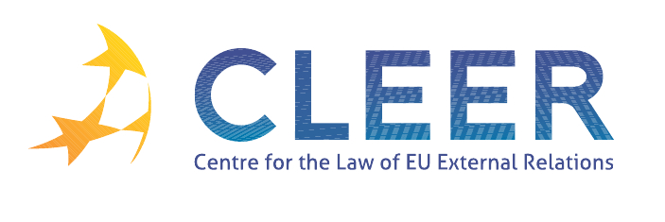

News Service week 4/2012

(23-29 January 2012)
- EU ENLARGEMENT
23 January | Croatian voters say yes to EU membership in referendum
24 January | Commissioner Füle acknowledges the Serbian leadership’s commitment to the European integration process

- EU-WIDER EUROPE
25 January | EC and EBU: Support for public media in transformation countries
25 January | Commissioner Füle supports the work of Belarusian human rights activists

- EU-IRAN
23 January | New EU sanctions target sources of finance for nuclear programme of Iran (Council conclusions on Iran )

- EU-MIDDLE EAST
23 January | Council conclusion on Syria
23 January | Council conclusions on the Middle East Peace Process
24 January | Commissioner Füle speaks before the EP’s Committee on Foreign Affairs: One year after the Arab Spring
24 January | High Representative Catherine Ashton travels to Israel and the occupied Palestinian territory
25 January | € 55,4 million goes to financing essential services for Palestine refugees in Gaza, the West Bank, Jordan, Syria and Lebanon

- CSDP
26 January European Defence Agency | 20th member state signs the European military airworthiness Basic Framework document

- TRADE
26 January | Trade MEPs call for action against child labour in cocoa production
27 January | EU highlights trade-led growth as central to modern development agenda
27 January | Trade, growth & development: tailoring trade and investment policy for those countries most in need (Commission communication COM(2012) 22 final)
27 January | Ten benefits of trade for developing countries

- DEVELOPMENT AND COOPERATION
23 January | Council welcomes political reform undertaken by the Government and Parliament in Burma/Myanmar
26 January | Cameroon: A million people to benefit from new EIB funded power plant

- EVENTS
26 January | ‘Translating mineral resource wealth into real development for Africa’ conference organised by European Commission DG Enterprise and Industry, Brussels, BE
26-27 March | ‘Family reunification procedures in EU migration law’ conference co-organised by ERA and the Latvian Judicial Training Centre, Riga, LA

Edited by Zsófia Deli & Dr. Tamara Takács

