`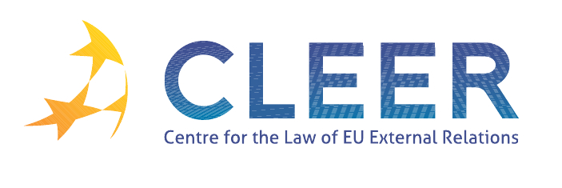

News Service week 1/2012

(1 – 8 January)

- DANISH PRESIDENCY
1 January | Launching of the Danish Presidency programme ‘Europe at Work’
3 January | Provisional agendas for Council meetings

- EU – WIDER EUROPE
1 January | EU reinstates trade preferences for the Western Balkans until 2015

- EU – MIDDLE EAST
3 January | EU welcomes the meeting of Israeli and Palestinian negotiators

- EU – CHINA
4 January | EU is concerned about the sentencing of human rights activists in China

- CFSP
3 January | CFSP Budget Report monthly update as of 31 December 2011

- EVENTS
Deadline: 16 January | Call for papers: ‘The Management of Migration and Asylum in Europe: Current Challenges and Policy Responses’ (conference organised by the University of Cambridge, UK, 15-16 March)
18 - 19 January | ‘EU Research Funding’, workshop organised by IES, Brussels, Belgium
19 January | ‘European Union Foreign Policy after Lisbon: The View from the Mediterranean’, roundtable organised by LSE, London, UK
24 January | ‘European SMEs and International Trade’, workshop organised by the Policy Department of DG EXPO, Brussels, Belgium
26 - 27 January | ‘The Governance of Asylum and Migration in the European Union’ conference organised by the University of Salford, UK
3 - 4 February | ‘EU External Relations in the Post-Lisbon Era’, conference organised by the BMW Center for German & European Studies, Washington DC, USA
10 - 11 February | ‘EU Studies Fair 2012’, conference organised by European Voice, Brussles, Belgium
Deadline: 17 February | Call for papers: ‘China and Europe in 21st Century Global Politics: Partnership, Competition or Co-Evolution?’ (conference organised by the Graduate School of Global Politics of Free University Berlin and the School of International Studies of Renmin, Beijing, China, 5-6 March)
Deadline: 24 February | Call for papers: ‘Creating a Sustainable Energy Future within the EU’ (conference organised by the University of Glasgow, UK, 2 March)

Edited by Zsófia Deli & Dr. Tamara Takács

