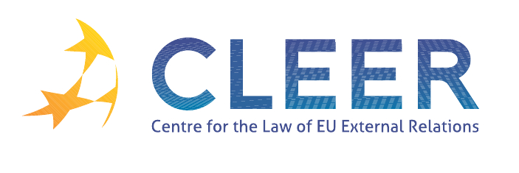

News Service week 50/2011

- EU ENLARGEMENT
12 December | Speech by Commissioner Štefan Füle at the third meeting of the Accession Conference with Iceland at Ministerial level: ‘Enlargement process on track with 5 more chapters open with Iceland’
13 December | Statement by Commissioner Štefan Füle on the launching of Montenegro’s accession process by the European Council
DG ECOFIN Occasional Paper | Progress towards meeting the economic criteria for accession: the assessments of 2011 Progress Reports and the Opinion (Serbia)

- EU-RUSSIA
12 December | EU-Russia Summit: EU27 trade in goods with Russia up by 27% in the first nine months of 2011
13 December | Speech of High Representative Catherine Ashton on the EU-Russia Summit
14 December | EU-Russia summit to improve citizen’s mobility

- CSDP
12 December | Fight against piracy: Council launches EU action to strengthen maritime capacities in the Horn of Africa

- CFSP
Legislation | Council Regulation No 1295/2011 of 13 December 2011 amending Regulation 1284/2009 imposing certain restrictive measures in respect of the Republic of Guinea

- EU EXTERNAL ACTION
7 December | Proposal for a Regulation of the European Parliament and of the Council establishing common rules and procedures for the implementation of the Union’s instruments for external action (COM(2011) 842 final)
7 December | Joint Communication to the European Parliament and the Council: ‘Global Europe: A new approach to financing EU external action’ (COM(2011) 865 final)

- DEVELOPMENT AND COOPERATION
7 December | Proposal for a Regulation of the European Parliament and of the Council establishing a financing instrument for the promotion of democracy and human rights worldwide
12 December | Worsening humanitarian situation in Yemen triggers a €5 million boost in European assistance
14 December | Sakharov prize laureates grateful for Europe’s support to Arab Spring
14 December | European development days in Warsaw to foster the link between democracy, human rights, and fight against poverty
14 December | EU development cooperation with South Sudan
15 December | Commission welcomes UN resolution on security of humanitarian workers
15 December | EU helps to further stabilise Libya through support for education, administration and civil society
15 December | Gender equality: encouraging first results of EU Gender Action Plan in developing countries
16 December | Erasmus Mundus: funding boost for Arab Spring countries
16 December | Helping in emergencies and long-term crises – where the European Commission’s humanitarian aid will go in 2012
Council Report | Regional Report on the Near East

- TRADE
13 December | Background note to Foreign Affairs Council meeting on Trade issues (14th December, Geneva)
14 December | Moving ahead industrial relationship with Brazil
15 December | Successful conclusion of the WTO’s government procurement negotiation: EU succeeds in gaining more market access
15 December | EU welcomes 3 new members to the World Trade Organisation

- EXTERNAL DIMENSION OF AFSJ
12 December | EUROSUR: ‘connecting the dots’ in border surveillance (COM(2011) 873 final )
12 December | EUROSUR: Providing authorities with tools needed to reinforce management of external borders and fight cross-border crime
13 December | Council gives green light for the new EU-US agreement on Passenger Name Records (PNR)
13 December | Single permit and a clear set of rights for legal migrant workers
16 December | OLAF and Chinese authorities join forces to fight cigarette smuggling from Asia
Commission Report | Report on the results achieved and on qualitative and quantitative aspects of implementation of the European Return Fund for the period 2007-2009 (COM(2011) 858 final)

Edited by Radka Mutlová & Dr. Tamara Takács

