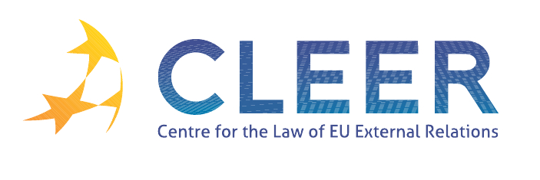

News Service week 49/2011

- EU-CROATIA
9 December | Accession treaty with Croatia signed
9 December | Background note to the signature of the Accession treaty
Commission Enlargement DG | Country profile

- EU ENLARGEMENT
5 December | General Affairs Council conclusions on enlargement and stabilisation and association process
7 December | EU continues to assist the enlargement countries through a revised Instrument for Pre-accession Assistance (IPA) (COM(2011) 838 )

- EU-WIDER EUROPE
Eurostat | Pocketbook on Euro-Mediterranean statistics

- EU-AFRICAN UNION
Eurostat | The European Union and the African Union: A statistical portrait

- EU-US RELATIONS
5 December | EU and US legislators step up their cooperation

- EU ACCESSION TO ECHR
Presidency Note | Accession of the Union to the European Convention for the Protection of Human Rights and Fundamental Freedoms: State of play

- EU EXTERNAL INSTRUMENTS
7 December | Strengthening Europe’s place in the world: An external budget for 2014-2020 to respect EU commitments and promote shared values

- EU EXTERNAL REPRESENTATION
2 December | EU High Representative Catherine Ashton selects five new Heads of EU Delegations

- CFSP
6 December | Political and Security Committee Decision 2011/814/CFSP on the establishment of the Committee of Contributors for the European Union military mission to contribute to the training of Somali security forces (EUTM Somalia)
6 December | Political and Security Committee Decision 2011/815/CFSP on the acceptance of third States’ contributions to the European Union military mission to contribute to the training of Somali security forces (EUTM Somalia)

- CSDP
1 December | CSDP - Council conclusions

- TRADE
5 December | EU launches trade negotiations with Georgia and Moldova

- DEVELOPMENT AND COOPERATION
5 December | EU provides additional support to security and peace in Somalia

- EXTERNAL DIMENSION OF AFSJ
ECJ Judgment | Case C-329/11 Achughbabian v Préfet du Val-de-Marne (FR) (Common standards and procedures in Member States for returning illegally staying third-country nationals)

Edited by Radka Mutlová & Dr. Tamara Takács

