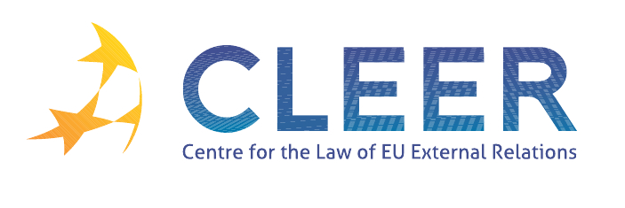

News Service week 48/2011

- EU-US SUMMIT
28 November | EU-US Summit to further strengthen the transatlantic partnership
28 November | Transatlantic Economic Council establishes ‘High-Level Working Group on Jobs and Growth’
28 November | EU-US Summit joint statement

- EU-UN RELATIONS
Mercury Paper | The European Union and the reform of the United Nations: Towards a more effective Security Council?

- EU ENLARGEMENT
28 November | Information on the results of the EU accession negotiations with Croatia

- WIDER EUROPE
28 November | EU boosts regional cooperation and border management in the Eastern Neighbourhood and Russia
29 November | Belarus: Štefan Füle meets with the opposition on European Future
1 December | European Parliament wants EU-Ukraine association agreement to go ahead
DG ECOFIN Occasional Paper | European neighbourhood economies: coping with new challenges
Mercury Paper | Multilateralism as envisaged? Assessing European Union’s engagement in conflict resolution in the Neighbourhood

- EU-ARAB WORLD
ISS Report | Egyptian democracy and the Muslim Brotherhood

- CSDP
24 November | EEAS document on ‘Actions to enhance EU CSDP support to UN peacekeeping’

- CFSP
1 December | Council Decision 2011/782/CFSP concerning restrictive measures against Syria and repealing Decision 2011/273/CFSP
1 December | Council reinforces restrictive measures concerning Iran (Council Decision 2011/783/CFSP amending Decision 2010/413/CFSP concerning restrictive measures against Iran )
1 December | Council Decision 2011/781/CFSP on the European Union Police Mission (EUPM) in Bosnia and Herzegovina (BiH)
ECJ Judgment | Case C-548/09 Bank Melli Iran (Restrictive measures against the Islamic Republic of Iran to prevent nuclear proliferation, freezing of the funds of a bank)
ISS Occasional Paper | Interparliamentary scrutiny of the CFSP: avenues for the future

- EU EXTERNAL REPRESENTATION
25 November | EU diplomatic representation in third countries - Second half of 2011

- AVIATION POLICY
1 December | Commission welcomes agreement on Siberian overflights

- DEVELOPMENT AND COOPERATION
28 November | EU measures for developing countries agreed
29 November | EU Fast Start Finance Report (Actions supported )
30 November | New initiatives announced to increase transparency and improve coordination in aid delivery
1 December | € 30.1 million EU support for the promotion of agricultural products in third countries
1 December | Key facts on the European Commission’s actions to fight HIV/Aids

- EXTERNAL DIMENSION OF AFSJ
24 November | Work programme 2012 of the European Asylum Support Office
ECJ Judgment | Case C-256/11 Dereci v Bundesministerium für Inneres (Right of residence of nationals of third countries who are family members of Union citizens, EEC-Turkey Association Agreement, ‘standstill’ clauses)

- EVENTS
Deadline: 12 December | Call for Papers: ‘Intra-institutional politics of EU energy policy-making: Landscape-level shifts, bargaining and organizational cultures’ (University of Cambridge, UK)
16-17 February 2012 | ‘Planning workable policies for migrant integration in the EU Member States’, Seminar organised by EIPA in Maastricht, NL

Edited by Radka Mutlová & Dr. Tamara Takács

