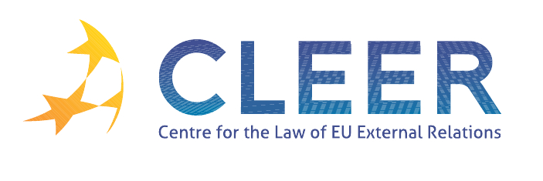

News Service weeks 46-47/2011

- EU-ENLARGEMENT
16 November | European Commissioners Füle and De Gucht visit Istanbul to strengthen new EU agenda with Turkey
Commission Report | Annual Report on the instrument for structural policies for pre-accession (ISPA) 2010 (Accompanying document to the Report )
EP Report | On the application of Croatia to become a member of the European Union

- TRADE
16 November | Agreement between the European Union and the Swiss Confederation on the protection of designations of origin and geographical indications for agricultural products and foodstuffs, amending the Agreement between the European Community and the Swiss Confederation on trade in agricultural products (Notice concerning the entry into force )
Eurostat | EU-USA Summit EU27 surplus in trade in goods with the USA of 35 bn euro in the first half of 2011; Deficit of 4 bn in trade in services in 2010
Eurostat | EU27 external trade in services rose by 10% in 2010
EP Report | Free Trade Agreement between the EU and Ukraine: Conceptual background, economic context and potential impact

- ENERGY POLICY
24 November | Council conclusions on strengthening the external dimension of the EU energy policy

- FOREIGN AFFAIRS COUNCIL MEETING
Background Note | 3124th Foreign Affairs Council meeting
14 November | Council Conclusions on Afghanistan
14 November | Council Conclusions on the Horn of Africa
14 November | Council Conclusions on Iran
14 November | Council conclusions on Libya
14 November | Council Conclusions on Somalia
14 November | Council Conclusions on Syria
14 November | Council Conclusions on the 10th European Development Fund Performance Review

- CSDP
16 November | Norway joins the European Air Transport Fleet

- ECONOMIC GOVERNANCE
15 November | Commission adopts 2012 Work Programme for European Renewal

- DEVELOPMENT, COOPERATION AND CRISIS MANAGEMENT
17 November | Cooperation with disaster management: the European Union and the United States take a major step forward
21 November | Additional € 1.5 million for most vulnerable drought victims in Afghanistan
21 November | EU development cooperation with Benin
22 November | EU announces closer working ties with Anna Lindh Foundation through a new joint programme for the revitalisation of Arab Civil Society
23 November | Development aid: Europeans show overwhelming support for helping world’s poor
24 November | EU-Chile: Laying the foundations for closer cooperation in disaster management
24 November | Commission announces support for Small and Medium-Sized Enterprises and research projects in Jordan
ISS Analysis | Global governance – building on the civil society agenda

- EU MIGRATION POLICY
Commission Communication | The Global Approach to Migration and Mobility (COM(2011) 743 final )
Green Paper | On the rights to family reunification of third-country nationals living in the European Union (Directive 2003/86/EC)

- EXTERNAL DIMENSION OF AFSJ
15 November | Future financing of Home affairs: More money, more flexibility, simpler rules

- EVENTS/VACANCIES
Deadline: 1 December | Call for Papers: ‘Transatlantic Conference on Transparency Research 2012’ (Utrecht University, NL)
Deadline: 9 December | Call for Papers: ‘China and Europe in 21st century global politics: partnership, competition, or co-evolution?’ (Renmin University in Beijing, CN)
Deadline: 15 December | Call for Papers: ‘Romanis in Europe’ (University Association for Contemporary European Studies (UACES), DE)
Deadline: 13 January , 2012 | Fellowship: Jean Monnet Center for International and Regional Economic Law & Justice (NYU School of Law)
Deadline: 13 January, 2012 | Call for Papers: ‘Collapsing Europe’ (Graduate Centre for Europe, University of Birmingham, UK)
Deadline: 15 January, 2012 | Call for Papers: ‘Sixth Pan-European Conference on EU Politics’ (University of Tampere, FI)
Deadline: 15 January, 2012 | Vacancy: Assistant Professor in European Union Policy, Vesalius College Brussels
Deadline: 20 January, 2012 | Call for Panels and Papers: University Association for Contemporary European Studies 2012 (UACES Conference 2012)

Edited by Radka Mutlová & Dr. Tamara Takács

