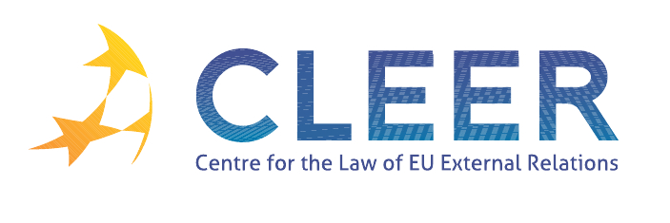

News Service weeks 44-45/2011

- EU ENLARGEMENT
1 November | Commission: Enlargement Newsletter

- EU - G-20 SUMMIT
30 October | Joint letter of the European Commission President José Manuel Barroso and European Council President Herman Van Rompuy to their G-20 partners ahead of the G-20 Summit
31 October | EU priorities at the G-20 summit
3-4 November | The EU at G-20 summit
4 November | Cannes Summit Final Declaration

- EU-TRANSATLANTIC RELATIONS
1 November | Joint press release by President of the European Council Herman van Rompuy and President of the European Commission José Manuel Barroso on the next EU-US Summit on 28 November in Washington, DC

- TRADE
31 October | WTO trade negotiations: Doha Development Agenda
3 November | Statement by President Barroso on the conclusion of a bilateral agreement between Georgia and Russia on Russia’s accession to the WTO
8 November | Council adopts regulation on export credits
8 November | Karel De Gucht, European Commissioner for Trade: ‘Looking beyond the crisis: Making the EU-China trade relations work’
9 November | Spotlight on trade negotiations with Canada
10 November | EU welcomes conclusion of negotiations on Russia’s WTO accession
CEPII-CIREM Study | Economic impact of potential outcome of the DDA II

- CFSP
3 November | CFSP Budget Report - Monthly update as of 31 October 2011

- DEVELOPMENT AND COOPERATION
31 October | EU - Australia ministerial consultations
31 October | Second operation of EU support to Turkey after the earthquake
3 November | EU-Israel: European Commission Vice President Antonio Tajani and Industry Minister Shalom Simhon sign space and tourism agreements
7 November | EU development cooperation with Uganda
7 November | EU announces new support for education for all in developing countries
8 November | World Bank and OLAF step up efforts to jointly combat fraud and corruption in development aid
8 November | New Commission support to increase income and create jobs for small and medium businesses in Egypt

- EXTERNAL DIMENSION OF AFSJ
8 November | Commission and the International Organization for Migration streamline their cooperation
AG Opinion | Joined Cases C-7/10 and C-9/10 Staatssecretaris van Justitie v Kahveci and Inan (EEC-Turkey Association Agreement, right of residence, family members of a Turkish worker who has acquired the nationality of the host Member State, date of naturalisation)

- EVENTS
November 2011 - January 2012 | ‘European Union Foreign Policy after Lisbon’, series of roundtables organised by LSE, London, UK
Deadline: 10 January 2012 | Call for Papers: ‘EU Energy Security and its Geopolitical Challenges’ (International Journal of Energy Security and Environmental Research)
Deadline: 15 January 2012 | Call for Papers: ‘Environmental Protection in the Global Twentieth Century: International Organizations, Networks and Diffusion of Ideas and Policies’ (Conference organised by KFG ‘The Transformative Power of Europe’, Berlin, 25-27 October 2012)
New journal | Global constitutionalism: Human Rights, Democracy and the Rule of Law (published by Cambridge University Press in association with the Centre for Globalization and Governance, University of Hamburg)

Edited by Radka Mutlová & Dr. Tamara Takács

