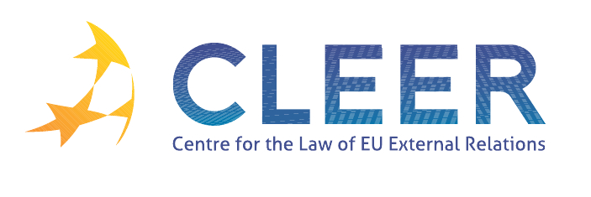

News Service week 35-36/2011
- EU-Libya
29 August | Commission established humanitarian presence in Tripoli and boosts funding for emergency operations in Libya’s capital
1 September | Council Implementing Decision 2011/521/CFSP implementing Decision 2011/137 concerning restrictive measure in view of the situation in Libya
Legislation | Council Implementing Regulation 872/2011 of 1 September 2011 implementing Article 16(2) of Regulation 204/2011 concerning restrictive measures in view of the situation in Libya
EU ISS Opinion | Libya: Getting it right (by Álvaro de Vasconcelos)

- EU-Syria
2 September | Council bans import of Syrian oil
2 September | Council Decision 2011/523/CFSP partially suspending the application of the Cooperation Agreement between the European Economic Community and the Syrian Arab Republic
Legislation | Council Regulation 878/2011 of 2 September 2011 amending regulation 442/2011 concerning restrictive measures in view of the situation in Syria

- CFSP
25 August | Council Decision 2011/518/CFSP appointing the European Union Special Representative for the South Caucasus and the crisis in Georgia
Judgment | Case T-208/11 Liberation Tigers of Tamil Eelam v Council (Action for annulment, freezing of assets)

- TRADE
Commission Communication | The EU Energy Policy: Engaging with Partners beyond Our Borders
Commission Report | Midterm evaluation of the Customs 2013 Programme
EP Report | New Trade Policy for Europe under the Europe 2020 Strategy

- DEVELOPMENT AND COOPERATION
31 August | EU reaffirms its support to peace and security in Africa with €300 million
EP Report | EU policy framework to assist developing countries in addressing food security challenges

- EVENTS
17-18 November | ‘Management and Control Structures for Migration Funds’, Conference organized by EIPA in Maastricht, NL
28-29 November | ‘EU External Relations and European-Level Diplomacy’, Seminar organized by EIPA in Maastricht, NL
9 December | ‘Recent Developments in EU Labour Migration Law: Focus on highly-skilled migration from third countries’, Conference organized by ERA in Brussels

Edited by Radka Mutlová & Dr. Tamara Takács

