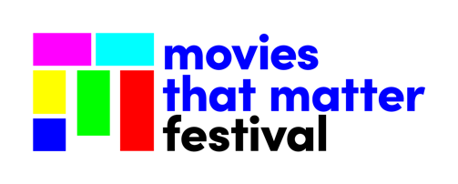
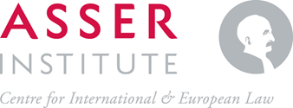

Provisional programme
Global Justice Cinema Workshop 2022
13-14 April 2022

Wednesday 13 April
Venue: Asser Institute
09:30 – Welcome and Introductions
10:00 – Lecture Conceptions of justice in documentary film – Prof. Wouter Werner (VU)
12:15 – Lunch break
13:15 – Lecture Storytelling through editing – Dr Sofia Stolk (Asser)
14:15 – Break
14:30 – Screening Freedom Swimmer
14:45 – Q&A with director Olivia Martin-McGuire
15:45 – Break

Move to festival venue
18:30 – Dinner at Stan en Co
20:30 – Screening Treasures of Crimea at Movies that Matter festival

Thursday 14 April
At festival venue Pathé Buitenhof – zaal 3
09:30 – Evaluation Treasures of Crimea
10:00 – Q&A with Myanmar Film Collective
11:15 – Break
11:30 – Lecture on impact and outreach – Julie Nederkoorn (Movies that Matter)
12:30 – Lunch break
13:30 – Case study on impact and outreach – Michael Liu (Leiden University)
14:30 – Closing discussion
15:30 – Break
16:30 – Masterclass with ICC prosecutor Karim Khan (regular festival programme) – Pathé Buitenhof zaal 4
18:00 – Closing dinner Dudok
20:00 – Camera Justitia Night, screening of Myanmar Diaries

