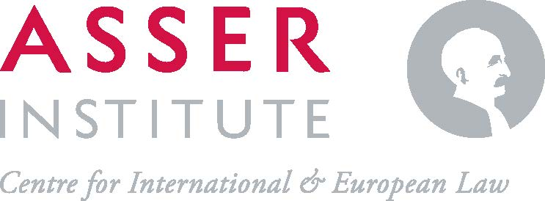

SUMMER PROGRAMME ON
SPORT AND HUMAN RIGHTS
2023

* PROGRAMME

Day 1 - Tuesday, 27 June – Sport and human rights

09:00 - 09:30 | Registration and coffee
09:30 - 10:15 | Opening and round of introductions
 | Dr Antoine Duval (Asser Institute), Dr Daniela Heerdt (Asser Institute)
10:15 - 11:30 | Why sport and human rights and whose human rights responsibilities?
 | Dr Antoine Duval (Asser Institute), Dr Daniela Heerdt (Asser Institute)
11:30 - 12:00 | Keynote speech I
Magali Martowicz (Head of Human Rights, International Olympic Committee)
(online)
12:00 – 13:00 | Lunch break
13:00 – 14:00 | Keynote speech II
Dr Giovanni di Cola (Officer in Charge of the ILO Office for Türkiye)
(online)
14:00 - 14:15 | Coffee break
14:15 - 16:00 | Sport & human rights in practice: Introducing the Centre for Sport and Human Rights
 | William Rook (CSHR) & Shubham Jain (CSHR)
16:00 – 17:00 | Group reflection
 | Led by Dr Antoine Duval (Asser Institute) & Dr Daniela Heerdt (Asser Institute)
18:30 | Opening dinner

Day 2 - Wednesday, 28 June – The Governance of Sport and Human Rights

09:00 – 10:30 | Sports bodies’ governance and human rights: An overview
 | Sylvia Schenk (Chair of the Working Group on Sport at Transparency International Germany, Member of the IOC Human Rights Advisory Committee and lawyer at Herbert Smith Freehills)
10:30 – 11:00 | Coffee Break
11:00 - 12:00 | The global governance of sport and human rights: Structures and institutions
 | Dr Antoine Duval (Asser Institute), Dr Daniela Heerdt (Asser Institute)
12:00 - 13:00 | Lunch Break
13:00 - 14:00 | Embedding human rights into sport policies and practices: Reflections from the national level
 | Dr Daniela Heerdt in conversation with Kirsten Witte-Abe (Deutscher Olympischer Sportbund)
14:00 - 14:15 | Coffee break
14:15 – 16:15 | Case study: FIFA’s human rights journey
 | Dr Andreas Graf (FIFA)
16:15 – 17:00 | Group reflection  Led by Dr Antoine Duval (Asser Institute) & Dr Daniela Heerdt (Asser Institute)

Day 3 - Thursday, 29 June – Athletes’ Rights

09:00 – 10:30 | Athletes and human rights: perspectives from Germany and the U.S.
 | Dr Daniela Heerdt in conversation with Maximilian Klein (Athleten Deutschland) and Yannick Kluch (University of Illinois)
10:30 – 11:00 | Coffee Break
11:00 - 12:30 | Safeguarding
 | Claudia Villa (Commonwealth Sport)
12:30 – 13:30 | Lunch Break
13:30 – 17:00 | The rights of professional football players
 | Alexandra Gomez Bruinewoud, Alex Culvin, Sarah Gregorius, Nienke van Gerven (FIFPRO)
17:00 – 18:00 | Closing Reception

Day 4 - Friday, 30 June– Gender and Sports

09:00 – 10:15 | Sport, human rights, and gender: An overview
 | Thays Prado (CSHR)
10:15 - 10:30 | Coffee Break
10:30 - 12:00 | Transgender athletes in the Olympic Movement
Madeleine Pape (International Olympic Committee)
(online)
12:00 – 13:00 | Lunch Break
13:00 - 14:00 | The Caster Semenya Case
Patrick Bracher (Norton & Fullbright)
(online)
14:00 – 15:00 | Sport, human rights, and gender: A research perspective
 | TBD
15:00– 16:30 | Final group reflection & closing
 | Led by Dr Antoine Duval (Asser Institute) & Dr Daniela Heerdt (Asser Institute)

*Note: This programme may be subject to change

